**Edina Trust Bulb Project Extension  
Guidance for Teachers and Project Leaders on this Year’s Results**

**A big thank you!**Well done to all schools that sent data for the Bulb Project this year! Your input has been invaluable in looking at our hypotheses. Even if you did not manage to get data to us this year, we hope that this project has been fun and useful for teaching various curriculum topics. We have a **quick survey online** where we would love to get your feedback:   
<https://www.surveymonkey.com/r/QP6H3TD>

Amgueddfa Cymru – Museum Wales (AC) will produce a paper on the results of the bulbs planted in pots for all schools. This will be distributed to the schools involved and can be accessed on the AC website: [www.museumwales.ac.uk/spring-bulbs/](http://www.museumwales.ac.uk/spring-bulbs/)

This year 100 schools took part in the Edina Trust’s extension Bulb Project, which involves comparing the flowering dates and heights between bulbs planted in pots and bulbs planted in the ground. **A big thank you to the schools that returned their data!**

|  |  |  |  |  |  |
| --- | --- | --- | --- | --- | --- |
|  | Scotland | England | N Ireland | Wales* | UK |
| Participating Schools | 34 | 39 | 24 | 80 | 177 |
| Schools that returned weather data | 28  (82%) | 29  (74%) | 20  (83%) | 45  (56%) | 122  (69%) |

*Only three Welsh schools took part in the Edina extension project this year, while 77 took part in the core Welsh project. For the weather data and flowering dates for bulbs in pots, the data from the core Welsh schools was included.

We have created a PowerPoint presentation that uses the weather data and flowering dates submitted by schools to compare differences across the UK as well as differences between this year and previous years of the project.

**We have also created some fun quizzes that pupils can do by themselves, which don’t require them to use PowerPoint. You can find more information on page 10!**

**Total Rainfall between November 2023 – March 2024   
recorded by schools**

|  |  |
| --- | --- |
| Country | Average rainfall (mm) |
| UK Average | 469 |
| Scotland | 383 |
| England | 467 |
| N. Ireland | 374 |
| Wales | 651 |

As is the case nearly every year, Wales had the most rain recorded! England was the second, then Scotland, and Northern Ireland had the least rain. These amounts are calculated by adding all of the rain recorded by each school together, and dividing it by the number of schools in each country, to get the mean.

We can compare these figures to the Met Office data to get a better idea of rain patterns across the UK. The map here shows the amount of rain from Winter 2024. We can see that a lot of England and Wales is blue (high rainfall), but there are drier patches in Scotland and Northern Ireland.

You can find out more information and look at weather summaries for the other months on the [Met Office website.](https://www.metoffice.gov.uk/research/climate/maps-and-data/summaries/index)

Water is of course vital for plants, but more rain does not always mean that daffodils will thrive. Daffodils will not grow underwater! Being too moist also benefits moulds that are detrimental to the daffodil bulbs. We would ask pupils to think about whether they expect bulbs to flower earlier if they get a lot of rain, or whether they would flower later?

**Average Temperature During the Bulb Project  
recorded by schools**

|  |  |
| --- | --- |
| Country | Average Temperature (°C) |
| UK 2023/24 | 7.6 |
| Scotland | 6.7 |
| England | 7.9 |
| N. Ireland | 7.2 |
| Wales | 8.4 |

This bar chart shows the average temperature when combining all the results between November and March to compare the differences between the countries. As expected, Scotland was the coldest again this year – but that isn’t always the case! Wales was the warmest country this year, meaning it was both the warmest and the wettest. Since spring bulbs require water and sunlight to grow, do you expect that they would flower first in Wales?

Bulbs are sensitive to temperature changes and begin to grow as the soil warms up in spring. This means that a mild winter can cause daffodils to flower earlier, or a cold spring can cause them to flower later.

As with rainfall, it is not always good to be too warm. As well as potential drought, too much warmth can be beneficial to pests such as the Large Narcissus Fly. The fly’s larvae live inside and eat daffodil bulbs. Due to the warmer climate this fly, which was once only found in the South-West, has been able to spread across the UK[1].

The Met Office report shows that the UK was generally warmer than average during Winter 2024, but with a few cold snaps such as at the beginning of December.

**Temperature each month between November 2022 – March 2023  
recorded by schools**

This graph shows the temperature each month from November 2023 – March 2024. We can see that the temperature dropped until January, and then it has risen in February and March. Wales was the warmest every month until March, where the average temperature in England jumped a little higher. Scotland was the coldest in every month.

Below are the average temperatures each month in each of the four countries:

|  |  |  |  |  |  |
| --- | --- | --- | --- | --- | --- |
| ºC | November | December | January | February | March |
| Scotland | 8.6 | 5.6 | 4.6 | 7.1 | 7.8 |
| England | 9.9 | 5.8 | 4.9 | 7.7 | 11.2 |
| N. Ireland | 8.7 | 6.2 | 5.2 | 7.3 | 8.4 |
| Wales | 10.3 | 7.4 | 6.0 | 8.1 | 10.2 |

Our hypotheses

Next, we look back at our hypotheses – our predictions about daffodils’ flowering and height:

1. Schools that record higher temperatures during the Bulb Project will have the earliest flowering daffodils. The effect of temperature will be more pronounced with the daffodils in pots compared to those in the ground.
2. Schools that record more daily rainfall during the Bulb Project will have the earliest flowering daffodils.
3. On average, daffodils in pots will flower before those planted in the ground.

|  |  |  |  |
| --- | --- | --- | --- |
|  | Pots | Ground | Average |
| Scotland | 12th March | 28th Feb | 5th March |
| England | 4th March | 7th March | 5th March |
| N. Ireland | 5th March | 2nd March | 3rd March |
| Wales | 3rd March | 4th March | 3rd March |

The results this year were very close, with the average flowering dates for bulbs in pots and in the ground together being on the same two dates, only two days apart! It’s hard to say that there was any significant difference this year. In order to give a result on where daffodils flowered first, we went with Northern Ireland as the bulbs in the ground flowered on the 2nd, which was the earliest result out of Northern Ireland and Wales.

This slide looks at the difference in dates between bulbs flowering in pots and those in the ground. Scotland had by far the longest gap with 13 days between bulbs in the ground flowering and bulbs in pots flowering. The other countries were a lot closer with only 1 – 3 days difference. We can’t be sure why this is. Perhaps the colder temperatures in Scotland had more of an effect, whereas the milder temperatures in other countries led to less of a difference. We also need to consider the other factors that could influence which bulbs grow and flower when we think about why our hypothesis was not correct.

Thank you to all the schools that reported their flowering dates or let us know that their flowers didn’t open. The more data we have, the more accurate our results ought to be. A big thank you to everyone who logged into the website to record their flowering dates/did not flower result!

The slide shows the difference in flowering dates between bulbs in pots and in the ground, and between Spring 2023 and Spring 2024. These are the average flowering dates across the whole UK.

Now we will look at the temperature and rainfall across multiple years of the Bulb Project to see if there are any differences. This year we can spot some interesting results...

This slide shows the average flowering date from the last five years of the project. The chart below shows the average temperature from each year. I have colour coded each point on the chart to make it easier to match to the year. Can you spot any pattern here? There is not a particularly clear trend. In 2020-21 and 2022-23 the flowering date was later, and the temperature was lower, but the results from 2023-24 don’t follow the same pattern.

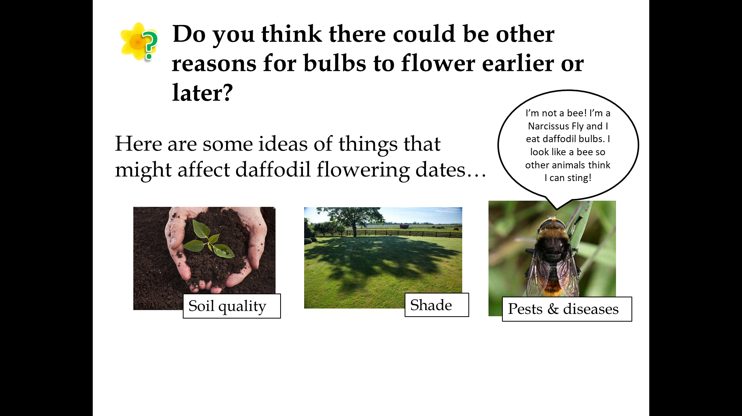The next slide looks at the rainfall. There is a higher amount of rainfall in the years where bulbs flowered earliest.

The slide shows some of our ideas for other factors that might be affecting the growth of the daffodils. They might explain why the results don’t always match our predictions. We ask pupils here to consider how they might change the Bulb Project to account for these factors. Some are easier to control than others! For example, perhaps we could ask all schools to use exactly the same type of compost, or to make sure the bulbs are planted in areas with full sun away from the school building, which can also warm the surrounding area slightly due to the buildings being heated. These are not practical to implement due to the nature of the project, but they would make the investigation more of a fair test.

1. Soil Quality

We cannot be sure how much of an effect the type of soil or compost has on the growth of daffodils. Compost will hold moisture more effectively than soil, and different types of compost will hold moisture more effectively – we recommend peat-free compost due to environmental concerns. Using compost over soil should also reduce weed growth since it should not contain any stray seeds. Good drainage is important as waterlogged soil can cause the bulbs to rot, and the pH and amount of nutrients (e.g. nitrogen and potassium), in the soil will also affect growth. We would have to find a way for all schools to use the same compost to eliminate this from our investigation. Differences in soil quality might affect bulbs planted in the ground more than those in pots due to the many different soil types that can be found in different areas of the UK.

1. Sunlight/Shade

Plants need sunlight in order to grow. Bulbs that are grown in shaded areas might grow taller in search of light, or they may not get enough sunlight to warm up and might flower later. We ask schools to keep their pots near the bulbs planted in the ground, if possible, to reduce the impact of this. There is not much else we can do as the amount of shade and hours of sunlight will differ between all schools.

1. Pests and Diseases

We don’t have much control over this. We advise schools to keep their bulbs in a cool, dry place before planting day. Let us know if you notice your flowers are affected by pests!

Finally we will look at the average height of daffodils in each country.

England had the tallest daffodils this year, and Scotland had the shortest. The height of daffodils can be highly variable. It may depend on the amount of rain and the temperature, and it can also be dependent on the amount of sunlight or the soil quality.

Mystery Bulbs

Spoilers: the mystery bulbs this year were a mix – you may have received either irises or grape hyacinths! Were you able to see the mystery bulbs flowering yet this year? They may open as late as May. We would like to encourage pupils to have a look for other spring bulbs flowering near where they live as well!

Follow Up Activities

1. Kahoot Quizzes

We have created some fun quizzes that pupils can complete using the website Kahoot! There are three different quizzes, relating to temperature and rainfall results sent in by pupils all around the UK. The separate rainfall and temperature versions are intended to be for higher ability levels, while the combined one for a lower ability level. The links to these quizzes can be found at [www.edinatrust.org.uk/bp-results](http://www.edinatrust.org.uk/bp-results)

We would love to hear your feedback!

1. Bulb Project Board Game

A professionally printed copy of this game was sent to all schools last October. However, if you direct pupils to our website linked below, they will find a board game that can be downloaded and printed. This game is designed to encourage discussion about the various factors that could have affected the growth of your daffodils and crocuses.

Please go to this web page to download the board game and instructions:

<https://www.edinatrust.org.uk/bp-results>

1. Investigate more results by looking at the Met Office Climate Maps and Data

You can look at climate summaries for each season and each month going back to 2018 among many other things. What patterns can you see? How do the results recorded by the Met Office compare to the Bulb Project results?

<https://www.metoffice.gov.uk/research/climate/maps-and-data>

1. <https://thedaffodilsociety.com/wordpress/a-guide-to-dafodils/pests-diseases/>